**New projects funded through fast-tracked £180 million new investment into storm overflows by water companies:**

Defra will keep pushing water companies to go further and recently announced a further £180 million of investment to improve the maintenance of the sewer network, on top of existing commitments to address the unacceptable performance. **South West Water have committed an additional £32 million in 2024** to deliver:

* Significantly increase Sewer Level Monitors by 31 March 2025.
* Increase sewer network cleansing in 2024 (already doubled in 2023).
* Increase structural defect repairs from 55 to 85 per month (Jan to June ’24).
* Double installation of power relays at pumping stations, which are key root cause of blockages.
* Divert groundwater at 30 key Wastewater Treatment Works.
* Doubling Wastewater Treatment Works generator services 30-60 per month (Jan to April ’24).
* Enhanced inspections at all Wastewater Treatment Works.
* Increase storm storage by adding over 6,000m3 additional capacity to the network.

**The Water Restoration Fund to provide up to £11 million available for local projects funded through water company fines and penalties**

Last April, the government published its [Plan for Water](https://www.gov.uk/government/publications/plan-for-water-our-integrated-plan-for-delivering-clean-and-plentiful-water/plan-for-water-our-integrated-plan-for-delivering-clean-and-plentiful-water) - which sets out how we are transforming our management of the water system with more investment, stronger regulation and tougher enforcement.

In the Plan for Water, we pledged to bring forward a Water Restoration Fund to further boost investment in our precious natural environment. This week, we are launching the Water Restoration Fund which will channel money from water company fines and penalties – paid from water company profits, not customers’ bills – into projects that support and improve our water environment. This will provide: eNGOs or other NGOs, members of protected landscapes, local authorities, landowners, land managers or farmers, catchment partnerships and other authorities or agencies not part of the UK central government (where there is not a statutory obligation in place) with an opportunity to bid for funding to carry out projects to improve our rivers, streams and lakes.

From re-meandering rivers and restoring water-dependent habitats, to removing barriers to fish migration and increasing sustainable public access to nature, the Fund will support a wide range of projects focused on improving the water environment and management of our rivers, including rivers, lakes, estuarine waters and wetlands, alongside restoring protected sites.

The Fund will be using environmental fines and penalties collected from water and sewerage companies in those areas between April 2022 and October 2023.

Applicants will be able to apply for development grants to build capability or delivery grants for on the ground projects. There is £2,150,000 available for applicants in the South West Water region.

We will always hold water companies to account, and it is only right that when they are fined by the courts or issued with penalties by regulators for environmental damage, that money is used to restore and protect our waters in the region where damage has been done.

**Devon, Cornwall, Scilly Isles. parts of Somerset and Dorset – South West Water (Water and Wastewater)**

**Existing planned or ongoing projects through the Accelerated Infrastructure Delivery Project**

In October 2022, Ofwat agreed accelerated additional infrastructure delivery in 2023-24 and 2024-25 dedicated to improving the functioning of the water system and to provide benefits for customers, communities and the environment. South West Water is delivering 4 projects:

1. Supply pipe leakage: Replacement of up to 9,760 customer supply pipes to reduce customer side leakage by 1.6 Ml/d by the end of 2024-25.
2. Nutrient neutrality: Delivery of nutrient removal at five of the sites identified as discharging into SAC rivers. The sites are Axminster Kilmington, Tatworth, Bodmin, Camelford, and Scarletts Well Wastewater Treatment Works.
3. Colliford smart metering: Installation of 40,116 advanced monitoring infrastructure meters, capable of recording and transmitting data at least once every 24 hours to measure supplies of water to premises and installation of 29,866 flow regulators.
4. Falmouth and Sidmouth Storm Overflows: Enhancements to 15 combined sewer overflows within the Falmouth and Sidmouth catchments to ensure compliance with bathing water quality standards, shellfish water standards and meet the Storm Overflow Discharge Reduction Plan spill target by March 2028.

Bristol Water is delivering the following project:

1. Supply pipe leakage and lead supply pipes: replacing up to 1,500 customer supply pipes.

**What other action is being taken on storm overflows?**

The government’s [Storm Overflows Discharge Reduction Plan](https://assets.publishing.service.gov.uk/media/6537e1c55e47a50014989910/Expanded_Storm_Overflows_Discharge_Reduction_Plan.pdf) will eliminate ecological harm from all storm overflows by 2050. It will protect biodiversity, the ecology of our rivers and seas, and the public health of our water users for generations to come.

While some claim that issue of storm overflow discharges can be resolved overnight, eliminating all discharges could cost between £120 billion and £600 billion, increasing annual water bills by between £271 and £817 per annum by 2049. To go from the targets set out in our Plan to zero discharges in an average year, water companies would need access to an additional 118.43 million m3 of storage – the equivalent of 40,000 Olympic sized swimming pools.

**Bathing Waters**

On 26 February, Defra launched a [consultation](https://consult.defra.gov.uk/water/consultation-on-designation-of-27-sites-as-bathing/) on the designation of 27 new bathing waters sites. Within Devon, Cornwall, Scilly Isles. parts of Somerset and Dorset, Bristol City, North Somerset. areas of Bath, North East Somerset and South Gloucestershire there are 8 proposed site: **River Frome at Farleigh Hungerford; River Avon at Fordingbridge; River Dart Estuary at Dittisham; River Dart Estuary at Steamer Quay, Totnes; River Dart Estuary at Stoke Gabriel; River Dart Estuary at Warfleet; Church Cliff Beach; Coastguards Beach**. Residents, bathers, businesses, and organisations were invited to have their say before the consultation closed on 10 March.

Bathing waters in England are a success story, with almost 90% achieving ‘Good’ or ‘Excellent’ status in 2023, up from just 76% in 2010, despite stricter classification standards being introduced in 2015. In the early 1990s, just 28% of bathing waters met the highest ‘guideline’ standards in force at that time. In 2023, 95.7% of bathing waters in England passed the minimum standard.

There are currently 424 designated bathing waters in England, the highest number ever (407 coastal, 14 lakes, 3 rivers). A list of current bathing sites in England, by local authority, can be found on [gov.uk](https://www.gov.uk/government/publications/bathing-waters-list-of-designated-waters-in-england/list-of-current-bathing-waters).

**Environment Agency and Natural England announcements and local activity**

The Environment Agency is leading a climate adaptation project at Pebblebed Heaths National Nature Reserve, [extending](https://www.gov.uk/government/news/vital-new-wetland-habitat-protected-with-announcement-of-a-new-kings-national-nature-reserve) the site by nearly 90 hectares, the equivalent of 128 football pitches, to encompass a unique wetland. The land covering the Lower Otter Restoration Project area at Budleigh Salterton is being added to the existing National Nature Reserve creating vital new wetlands.

The Environment Agency has also [posted on social media](https://twitter.com/EnvAgencySW/status/1757729181893296447?s=20), to inform the public about waterway discolouration and ask pollution incidents be reported directly to the EA.

**Regional Maps of Water and Wastewater Companies**

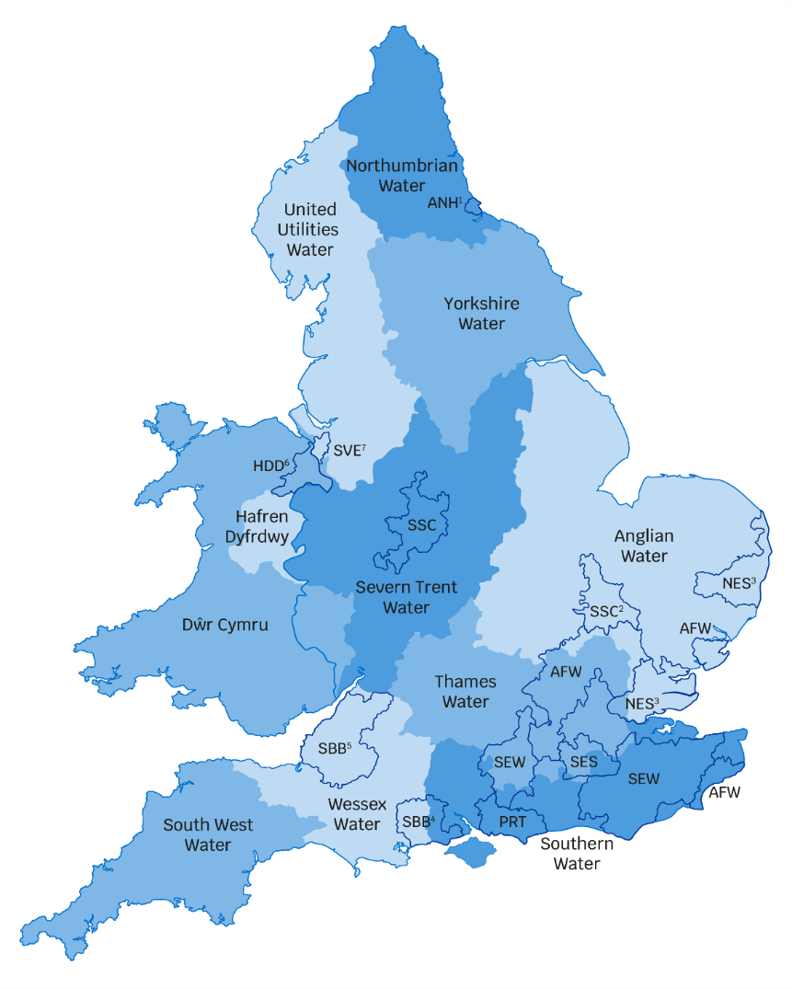

 

Liberal Democrat

Sarah Dyke

Labour

Damien Egan